OUTSEATS PARISH COUNCIL
Clerk: Peter Leppard Sickleholme Cottage
Telephone 07860 624453 Saltergate Lane
E-mail clerk.outseatspc@gmail.com Bamford
S33 0BE

6 December 2014
To: The Chairman and Councillors of Outseats Parish Council

Dear Councillor
You are hereby summoned to attend an extraordinary Parish Council Meeting on 11 December 2014 in the Sampson Room, Hathersage Memorial Hall at 7.30pm.
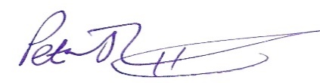 Peter Leppard, Clerk to Outseats Parish Council
AGENDA
MEMBERS OF THE PUBLIC AND PRESS ARE WELCOME TO ATTEND
- To receive apologies for absence
- Variations in Order of Business
- Declarations of Members’ Interests
  - To receive any declarations of Members' Interests (especially Disclosable Pecuniary Interests)
  - To receive and approve requests for dispensations from members on matters in which they have a Disclosable Pecuniary Interest
- Public Speaking - A period of not more than ten minutes will be made available for members of the public to comment about parish council matters
- Finance Matters in respect of the successor Parish Council (from April 2015) to Outseats PC
  - To review budget proposals from each of the Parish Councils to be succeeded by the new PC
  - To decide any adjustments needed to those proposals in order to achieve a satisfactory overall budget for the new PC
- Parish Matters
  - To consider other matters arising from creation of the new Parish Council from April 2015.

