OUTSEATS PARISH COUNCIL
Clerk: Peter Leppard Sickleholme Cottage
Telephone 07860 624453 Saltergate Lane
E-mail clerk.outseatspc@gmail.com Bamford
S33 0BE

21 October 2014
To: The Chairman and Councillors of Outseats Parish Council

Dear Councillor
You are hereby summoned to attend a Parish Council Meeting on 27 October 2014 in the Sampson Room, Hathersage Memorial Hall at 7.30pm.
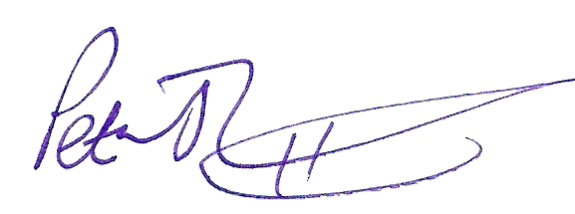 Peter Leppard, Clerk to Outseats Parish Council
AGENDA
MEMBERS OF THE PUBLIC AND PRESS ARE WELCOME TO ATTEND
- To receive apologies for absence
- Variations in Order of Business
- Declarations of Members’ Interests
  - To receive any declarations of Members' Interests (especially Disclosable Pecuniary Interests)
  - To receive and approve requests for dispensations from members on matters in which they have a Disclosable Pecuniary Interest
- Public Speaking
  - A period of not more than ten minutes will be made available for members of the public to comment about parish council matters
  - To receive reports on matters relevant to the Parish from:
    - Derbyshire Constabulary
    - County & District Councillors
    - Hathersage Parish Councillors
- To confirm the minutes of:
  - the Parish Council meeting held on 22 September 2014
  - the Planning Committee meeting held on 30 September 2014
- Highways/Footpaths
  - To review the parish’s gritbin arrangements for the coming winter
  - To review recent developments regarding access to Long Causeway
  - To review the situation regarding the surface, etc of Hurstclough Lane
  - To review the situation regarding access to Footpath 21
- Planning
  - To note PDNPA’s decisions re applications
    - NP/DDD/0814/0805 (Shelton, Coggers La)
    - NP/DDD/0814/0811 (7 Derwent La)
    - NP/DDD/0514/0490 (Lone Oak, Coggers La)
- Finance Matters
  - To receive statement of accounts as at 30 September 2014
  - To approve accounts for payment (total sum £226.32):
- Clerk – salary, office allowance and expenses for October £206.32
- DALC – training course, D Palmer £20.00
- Correspondence received
  - None at date of this agenda
- To receive the following items for information:
  - Sent by email:
Derbys Assoc of Local Councils Circulars 20/, 21/ & 22/2014
Hathersage PC Agenda 7/10/14
HPC Recreation Committee Minutes 16/9/14
HPC Swimming Pool Committee Minutes 9/9/14, Agenda 14/10/14
Hthsg & Outseats Jt Transport Committee Agenda 20/10/14
Hathersage Memorial Hall Minutes 8/9/14
Heart for Hathersage Minutes 15/9/14 & 14/10/14
Rural Services Network Weekly information emails
- To receive brief reports on meetings of Committees & outside bodies:
  - Hathersage Parish Council
To receive a brief report on the last Hathersage PC meeting
To appoint a representative to attend the Hathersage PC Meeting on 4/11/14
  - HPC Swimming Pool Committee
  - HPC Recreation Committee
  - Joint Transport Committee
  - Website Committee
  - Memorial Hall Committee
  - Churchyard/Church Charities
  - Allotments Group
  - Heart for Hathersage Group
  - Hope Works Liaison Committee
  - Stanage Forum
- Parish Matters and items for next Agenda
  - To consider next steps regarding setting up the new Parish Council from April 2015
  - To consider marking in some way, at its demise, the one-time existence of Outseats Parish
- Dates of next meetings
  - The two next meetings to be confirmed as Mondays 24 November and 26 January at 7.30pm at Hathersage Memorial Hall.

