OUTSEATS PARISH COUNCIL

Clerk: Peter Leppard Sickleholme Cottage
Telephone 07860 624453 Saltergate Lane
E-mail clerk.outseatspc@gmail.com Bamford
S33 0BE

25 February 2015

To: The Chairman and Councillors of Outseats Parish Council

Dear Councillor
You are hereby summoned to attend a Parish Council Meeting on 2 March 2015 in the Sampson Room, Hathersage Memorial Hall at 7.00pm.
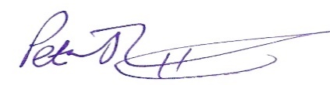 Peter Leppard, Clerk to Outseats Parish Council
AGENDA
MEMBERS OF THE PUBLIC AND PRESS ARE WELCOME TO ATTEND
- To receive apologies for absence
- Variations in Order of Business
- Declarations of Members’ Interests
  - To receive any declarations of Members' Interests (especially Disclosable Pecuniary Interests)
  - To receive and approve requests for dispensations from members on matters in which they have a Disclosable Pecuniary Interest
- Public Speaking
  - A period of not more than ten minutes will be made available for members of the public to comment about parish council matters
- To confirm the minutes of the Parish Council meeting held on 23 February
- To consider, and ratify if felt appropriate, proposals (in connection with the new parish from 1 April) from the Joint Staffing Committee

