OUTSEATS PARISH COUNCIL
Clerk: Peter Leppard Sickleholme Cottage
Telephone 07860 624453 Saltergate Lane
E-mail clerk.outseatspc@gmail.com Bamford
S33 0BE

2 March 2015
Dear Councillor
You are hereby summoned to attend a Planning Committee meeting to be held at 5.30pm on Friday 6 March 2015 in the Old Shippon Bunkhouse, Thorpe Farm, Outseats.
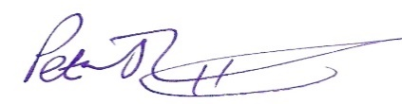 Peter Leppard, Clerk to Outseats Parish Council

AGENDA
MEMBERS OF THE PUBLIC AND PRESS ARE WELCOME TO ATTEND

- To receive apologies for absence
- Declarations of Members’ Interests

2.1 To receive any declarations of Members' Interests (especially Disclosable Pecuniary Interests)

2.2 To receive and approve requests for dispensations from members on matters in which they have a Disclosable Pecuniary Interest
- Public Speaking
  - A period of not more than 10 minutes will be made available for members of the public to submit comments.

- To consider the following planning application and make recommendations to PDNPA:
4.1 NP/DDD/0215/0112 North Lees campsite (installation of 4 camping pods & 2 new showers, changing location of reception area, replacement of metal windows with wooden)

