HATHERSAGE AND OUTSEATS PARISH COUNCILS’

JOINT WEBSITE COMMITTEE

Sickleholme Cottage
Clerk: Peter Leppard Saltergate Lane
Telephone 07860 624453 Bamford
E-mail clerk.outseatspc@gmail.com S33 0BE

10 January 2015

Notice is given that there will be a meeting of the Joint Website Committee on Thursday 15 January 2015 at 7.30 pm in the Sampson Room, Hathersage Memorial Hall.
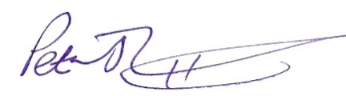Peter Leppard, Clerk to the Committee

AGENDA
- Election of Chair

- To receive apologies for absence

- Variations in Order of Business

- To receive any declarations of Members' Interests (especially Disclosable Pecuniary Interests)

- Public Speaking - A period of not more than ten minutes will be made available for members of the public to ask questions or submit comments about parish website issues.

- Review of design and content of the parish website - in light of the April 2015 change to Parish Council structure

- Longer-term development options for the parish website

- Date of next meeting

MEMBERS OF THE PUBLIC ARE ENTITLED TO ATTEND ALL MEETINGS OF THE COMMITTEE (SUBJECT TO CERTAIN RESTRICTIONS) AND WILL BE MADE WELCOME.

