HATHERSAGE PARISH COUNCIL
Clerk – Mrs A P Jones ; The Old Surgery, 39 Valley Road, Barlow, N E Derbyshire, S18 7SL
Tel: 0114 289 1854; Mob: 07443 508 357; Email: HathersageParishClerk@hotmail.co.uk

21st October 2015

Transport Committee members,

Notice is given that there will be a meeting of the Transport Committee, at the Bell Room, Hathersage at 7.30 pm Monday 26th October 2015. The Agenda for the meeting is set out below.
Yours sincerely,
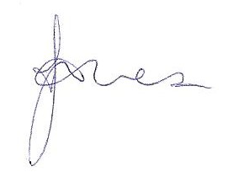
Clerk
PUBLIC PARTICIPATION

A period of not more than ten minutes will be made available on the agenda for members of the public to ask questions or submit comments about Transport Committee matters.

AGENDA

1 |  | Apologies for Absence
2 |  | To decide any variation in the order of business.
3 |  | Declaration of interests.
4 |  | Public participation – an opportunity for any members of the public to make any representation to the Transport Committee in respect of items on this agenda.
5 |  | To approve the minutes of the 21st September 2015 Transport Committee meeting and note any matters arising.
6 |  | Hope Valley Capacity Scheme – Draft a response to Network Rail Proposal.
7 |  | To identify items for the next meeting agenda.
8 |  | To agree a date for the next meeting.

MEMBERS OF THE PUBLIC ARE ENTITLED TO ATTEND ALL MEETINGS OF THE COUNCIL (SUBJECT TO CERTAIN RESTRICTIONS) AND WILL BE MADE WELCOME. WITH THE PERMISSION OF THE COUNCIL, MEMBERS OF THE PUBLIC MAY ADDRESS THE COUNCIL DURING THE TIME SET ASIDE FOR THE PURPOSE, UPON ITEMS APPEARING ON THIS AGENDA.

