HATHERSAGE PARISH COUNCIL
Clerk – Mr. S. C. Wyatt, Heart of Hathersage, Main Road, Hathersage, S32 1BB.
Mob: 07 432 422 470
Email: Clerk@hathersageparishcouncil.gov.uk
2nd June 2019

HR Committee members,
Notice is given that you are summoned to attend a meeting of the HR Committee in the HoH, Hathersage on 3rd June at 6.30 pm. The Agenda for the meeting is set out below.
Yours sincerely,
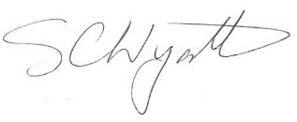
Clerk for Hathersage Parish Council.

AGENDA
1 |  | Appoint Chair and Vice Chair.
2 |  | To note Apologies for Absence.
3 |  | To decide any variation in the order of business.
4 |  | Declaration of interests.
5 |  | Review Committee Terms of Reference.
6 |  | Staff Contracts.
7 |  | Pool closure and wages during autumn works
8 |  | Staff reviews.
9 |  | Clerk’s Report/Correspondence.
10 |  | Items for next meeting.
11 |  | Confirm date of next meeting.

This is a closed meeting and not open to public attendance due to the personal and confidential matters that may be discussed. The minutes of the meeting will be recorded and presented to Hathersage Parish Council at its next meeting.

