HATHERSAGE PARISH COUNCIL
Clerk – Mr. S. C. Wyatt, Heart of Hathersage, Main Road, Hathersage, S32 1BB.
Mob: 07 432 422 470
Email: Clerk@hathersageparishcouncil.gov.uk
29th August 2019

HR, Grievance and Complaints Committee members,
Notice is given that you are summoned to attend a meeting of the HR Committee in the Sampson Room, Hathersage Memorial Hall on 4th September at 7.30 pm. The Agenda for the meeting is set out below.
Yours sincerely,
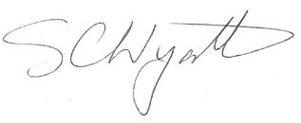
Clerk for Hathersage Parish Council.

AGENDA
1 |  | To note Apologies for Absence.
2 |  | To decide any variation in the order of business.
3 |  | Declaration of interests.
4 |  | Approve minutes of the meeting 26th June 2019.
5 |  | Pool closure and wages during autumn works – update.
6 |  | Staff 1:1 feedback.
7 |  | Bank Holiday Staffing issues.
8 |  | Complaints received.
9 |  | Pool staff job descriptions.
10 |  | Role of professional advisor.
11 |  | Clerk’s Report/Correspondence.
12 |  | Items for next meeting.
13 |  | Confirm date of next meeting.

This is a closed meeting and not open to public attendance due to the personal and confidential matters that may be discussed. The minutes of the meeting will be recorded and presented to Hathersage Parish Council at its next meeting.

