HATHERSAGE PARISH COUNCIL
Clerk – Mr. Steve Wyatt, Heart of Hathersage, Main Road, Hathersage, Derbyshire, S32 1BB
Mob: 07 432 422 470 Email: clerk@hathersageparishcouncil.gov.uk 27th November 2019

To the Members of Hathersage Parish Council.
Dear Councillor, You are summoned to attend an Extraordinary Meeting of Hathersage Parish Council at 7:30pm on Monday 16th December 2019 in the Stanage Hall, Memorial Hall, Oddfellows Road, Hathersage. The Agenda for the meeting is set out below.
Yours sincerely,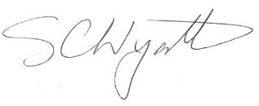Clerk for Hathersage Parish Council
AGENDA
1 |  | To receive apologies for absence.
2 |  | To decide any variation in the order of business.
3 |  | Declaration of Members Interests.
4 |  | Public Participation.
 |  | A period of not more than ten minutes will be made available for members of the public and Members of the Council to comment on any matter.
5 |  | Financial Matters
5 | .1 | To discuss additional expenditure on the swimming pool works for the new pumping and filtration plant.
6 |  | To confirm the next HPC meeting will be at 7.30 pm Tuesday 7th January 2020 in the School Hall.
7 |  | To note items for the 7th January 2019 agenda.

