HATHERSAGE PARISH COUNCIL
Clerk – Mr. Steve Wyatt, Heart of Hathersage, Main Road, Hathersage, Derbyshire, S32 1BB
Mob: 07 432 422 470 Email: clerk@hathersageparishcouncil.gov.uk
7th October 2020
To the Members of Hathersage Parish Council.

Dear Councillor, You are summoned to attend the on-line extraordinary meeting of Hathersage Parish Council at 8:00pm on Tuesday 13th October 2020. Join Zoom Meeting https://us02web.zoom.us/j/9491678155 Meeting ID: 949 167 8155. For audio only dial 0203 901 7895 followed by the meeting ID, calls charged at your providers rate for UK national calls.

The Agenda for the meeting is set out below.
Yours sincerely,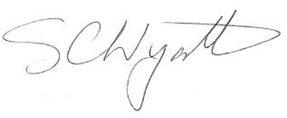Clerk for Hathersage Parish Council

AGENDA
1 |  | To receive apologies for absence.
3 |  | Declaration of Members Interests.
4 |  | Public Participation.
 |  | Committees and Working Groups
5 |  | Swimming Pool Committee.
5 | .1 | To discuss and approve the recommendation from the SPC with regards winter season tickets for forthcoming season.
6 |  | To confirm the next HPC on-line meeting will be at 7.30 pm Tuesday 3rd November 2020.
7 |  | To note items for the 3rd November 2020 agenda.

